想了解學程訊息，要去那裡得知學程訊息呢？
where can you go to obtain program details If you want to find information about a program.
教務處網頁有全校跨領域學程介紹連結：
 The Office of Academic Affairs website has a link to the introduction of school-wide interdisciplinary programs：
(位置： 首頁 教務處 學生專區 學程申請 跨領域學程一覽表)
( location： Homepage office of academic affairs Students’ Resource Application Program The List of Interdisciplinary Course Program)
https://www.yzu.edu.tw/admin/aa/index.php/tw/2016-01-14-06-58-46/2016-03-13-13-02-53/interdisciplinary-course-program
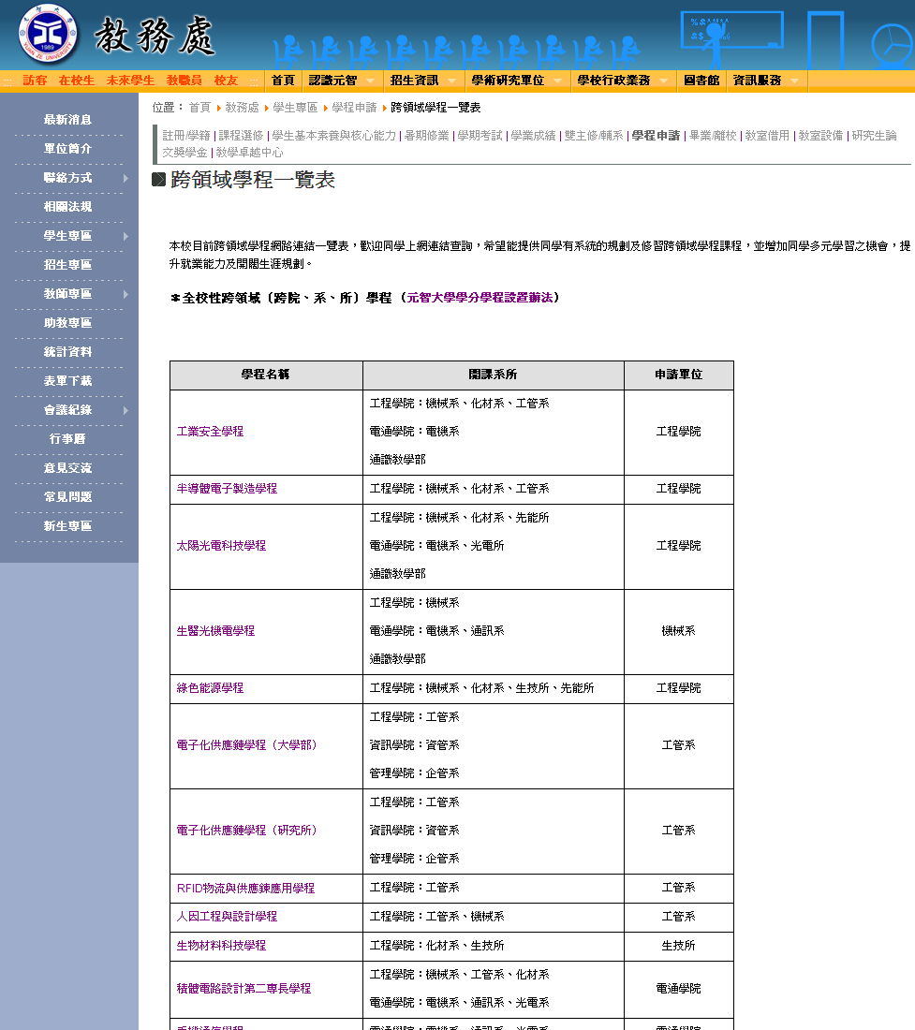

於「課程資訊」中查詢各學程課程訊息：
 You can find information about various program courses under "Course Information."：
(首頁 選課系統 元智大學課程查詢系統)
(HomepageYuan Ze University - University CurriculumGo To University Curriculum)
https://portalfun.yzu.edu.tw/cosSelect/Index.aspx
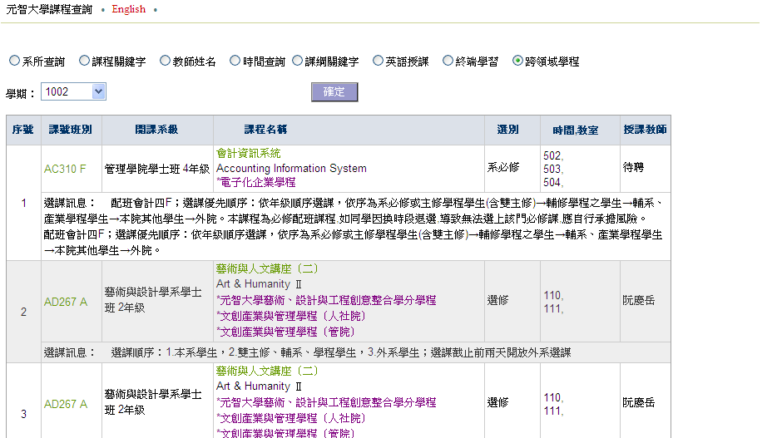

Ž

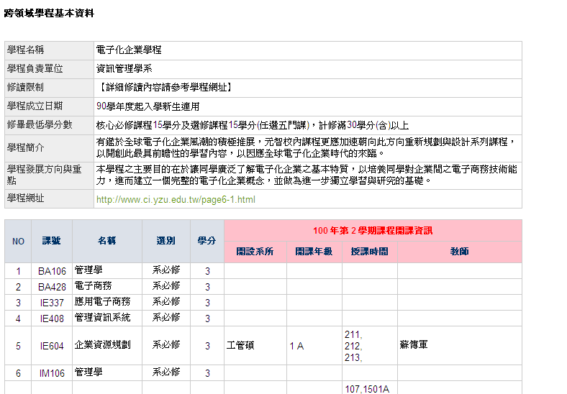

教務處/課務組 100.11製

學生於個人portal中課表可檢視修習課程與各學程之關聯性
● Students can view the relationship between their enrolled courses and various programs within their personal portal's course schedule.
(個人portal 學習檔案 課表)
(personal portal Learning Profile Course Schedule)
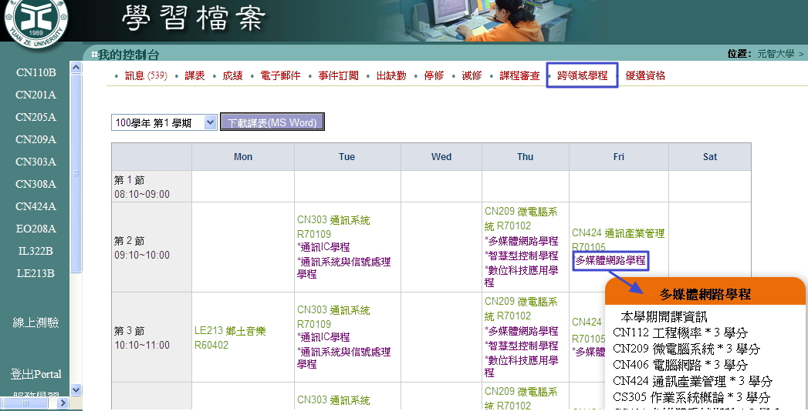



如何線上申請學程？
❍ How to apply for a program online?
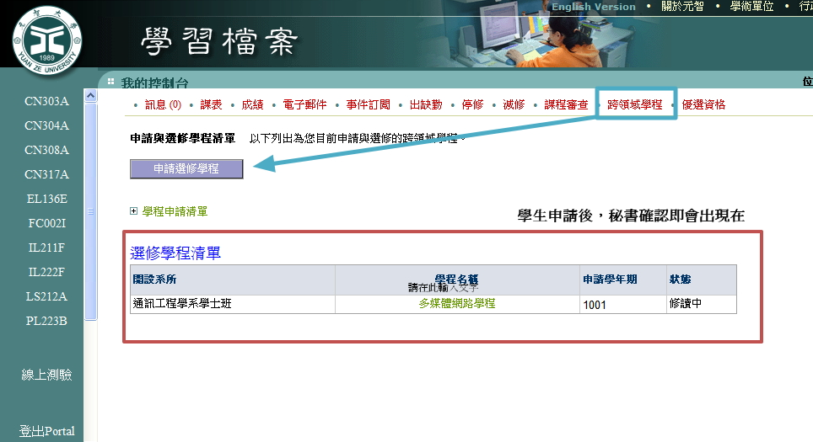
學生點選申請
修學程
(個人portal
學習檔案
跨領域學程)
Students click申請選修學程
(personal portal
learning profile
Interdisciplinary program)

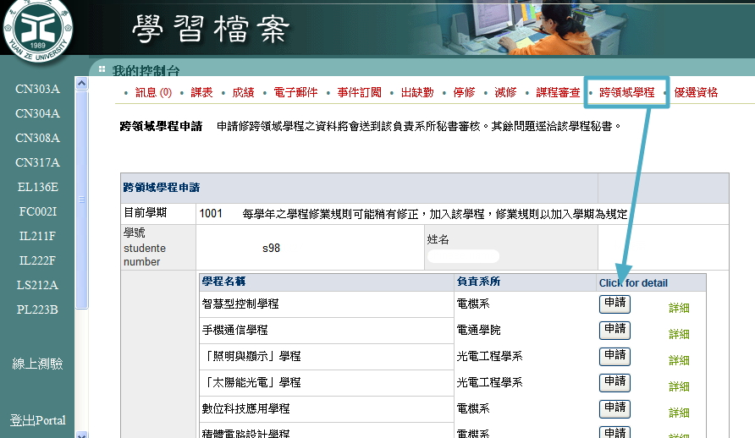

2.1學生針對將要修讀
的學程，點選申請。Students can click 'Apply' for the program they intend to enroll in.

2.2秘書請於秘書代工
中點選同意或不同意。The secretary, please select 'Agree' or 'Disagree' under the secretary's approval.

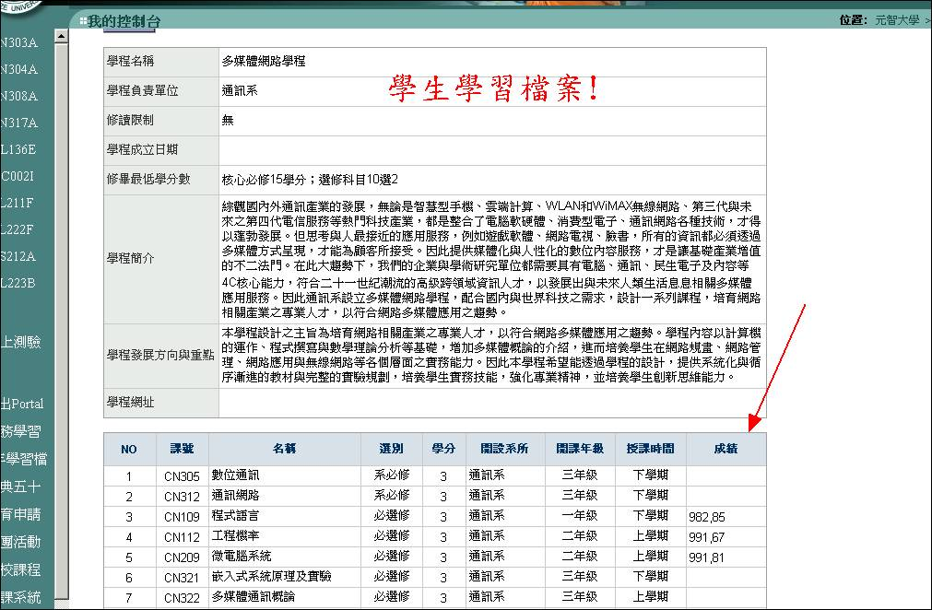
3.1學程秘書同意該生修讀該學程
後，即會出現在學生的學程申請
清單中。並帶出該生已修過之課
程年度及成績。
After the Program Secretary approves the student's enrollment in the program, it will appear in the student's program application list. It will also display the academic years and grades for courses the student has already completed.

